**Blueprint communication**

**Interface**

Create Third person template

Import 3 weapons from Maya or other

Create actors with each weapon

Create widget to display the inventory

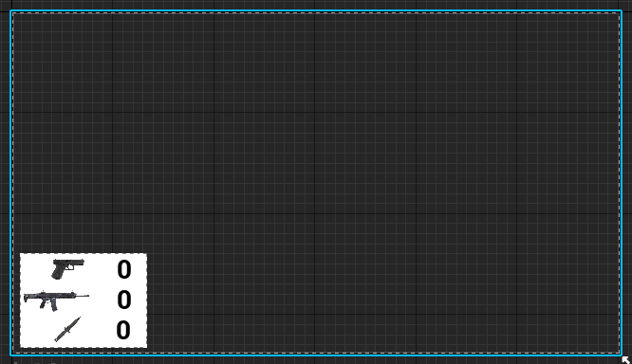

Add HUD and add following BP to HUD

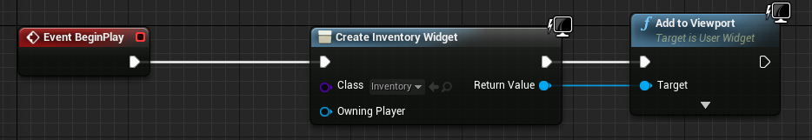

create BP interface and name it “Pickups”

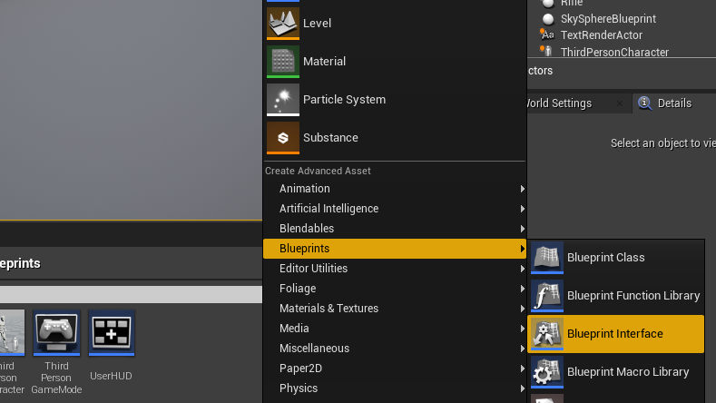

Create 3 functions in BP interface (KnifePickup, HandGunPickup, RiflePickup)

No need to add any script

Add BPInterface to class settings of character

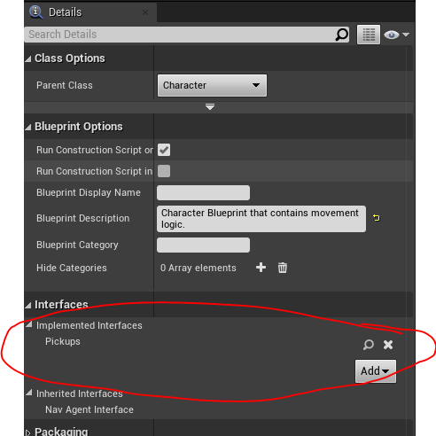

On Each weapon actor OnBeginOverlap send appropriate Interface Message as follows

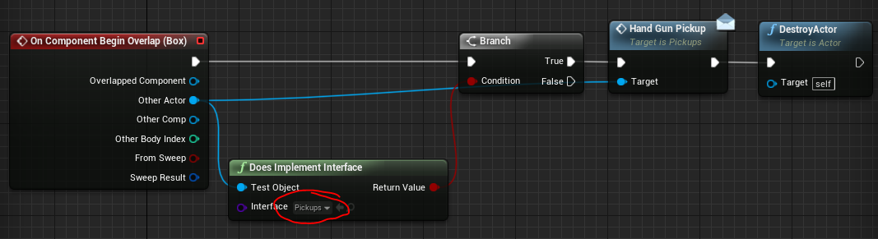

On character add event for each actor.

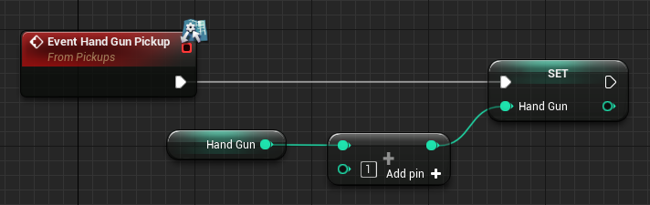

Need to add binding for the widgets

**Event Despatcher**

Create a door actor

Add custom event called “OpenDoor” and add following BP

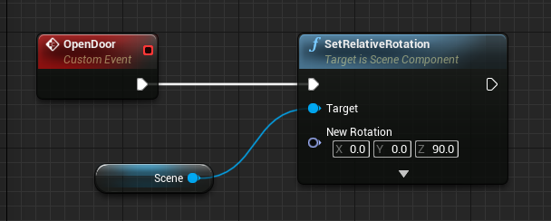

Create an actor called “Button” and add following BP

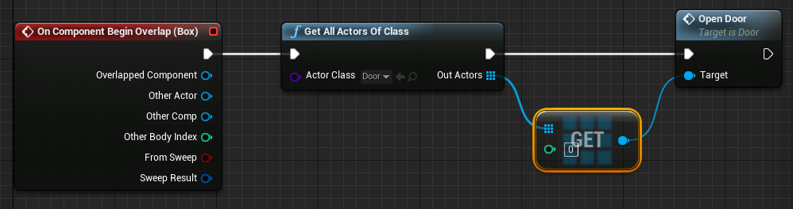

If we have two doors this method will not work. So we use event despatcher

Add event despatcher in the button

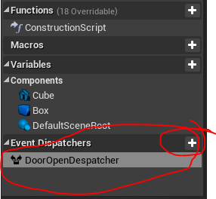

Drag the event despatcher in and pick the call option

Add the following BP

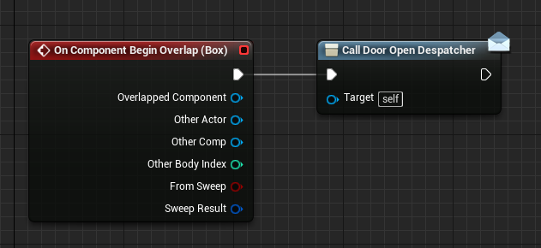

Go to Door and add the following BP

